Part 1- Originator
Originator: Section: |  |  | NC Section: |  |  |  |  |  |  | Date:
If nonconformity is existing, tick here for corrective action |  |  |  |  | If nonconformity is minor tick here
If nonconformity is potential , tick here for preventive action |  |  |  |  | If nonconformity if major tick here
How was the nonconformity identified?
Internal Audit |  | Management Review |  |  |  |  | Quality Control
Customer Complaints |  | Supplier Suggestion |  |  |  |  | EQA
Staff Observation |  | Safety Incident |  |  |  |  | Other(Specify)
Description of nonconformity (Existing or potential) and objective evidence

Part 2 Responsible Staff
Name: Section: Date Received:
Immediate action taken to mitigate deficiency (Correction), if required

Target action date: ________________ Extended to:_____________ Nonconformity No:______________________

Q O’s signature: TS/HOS’s signature: Date:
Nonconformity assigned to: Name: Section: Date:
Part 3- Assigned person
Root cause analysis

Proposed corrective or preventive action

Part 4- Technical Supervisor/ Head of Section approval
Comment  Name: Signature: |  |  |  |  |  |  |  |  | Approved
 |  |  |  |  |  |  |  |  | Not approved
 |  |  |  |  |  |  |  |  | Date:
Part 5 –Execution of Proposed Action
Action taken

Completion date: Agreed Closure Date: Signature:
Part 6- Close out/ Verification for Effectiveness
Head of Section | Technical Supervisor |  |  |  |  |  |  | Quality Officer
Action effective/not effective | Action effective/not effective |  |  |  |  |  |  | Action effective/not effective
Sign off:_____________________ | Sign off:_____________________ |  |  |  |  |  |  | Sign off:_____________________
Date:_______________________ | Date:_______________________ |  |  |  |  |  |  | Date:_______________________
 |  |  |  |  |  |  |  | New NC No. if required___________

Root cause analysis.
Step 1, Cause and Effect Diagram

- Categorize probable causes of nonconformity (NC) under six headings namely Machinery, Methods, Measurement, Manpower, Materials and Milieu (environment). These process components are sometimes referred to as the 6Ms.
- Using objective evidence, examine each probable cause. Evaluate each of the process components using but not limited to the guidelines below. Basing on the evaluation, eliminate the process components which are less likely associated with nonconformity.

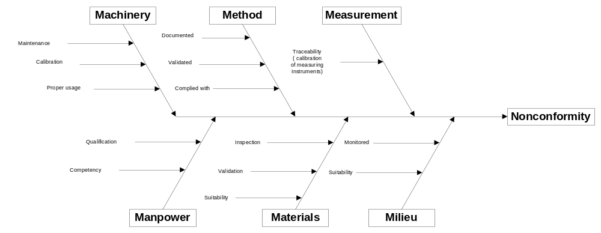
Step 2, 5 WHY’S

- Using the process component(s) identified in step 1, ask and keep asking why until satisfied that the answer showed what is really the source of the problem. The why’s do not necessarily have to be five. Five was chosen because it was proved with experience that when one asks why five times, he/she ends with the right information to go and fix the problem

Example
Problem. Personnel not certified competent
- Why? - Staff are not aware of the need for competency assessment
- Why? - Staff not trained on the procedure for competency assessment
- Why? - Quality Officer thought the procedure was covered during training
- Why? - No records of training are kept
- Why? - Procedure of training does not mention the need to keep records

Root Cause: The procedure for training does not fully address the needs for record keeping. To improve the system, revise the procedure for training.

